**COAL LAB 9**

**Question 1**

Include Irvine32.inc

.data

str1 BYTE "Enter an integer: ",0

.code

main PROC

mov edx, offset str1

call writestring

call readdec

MOV ebx, eax

MOV edx, eax

SHL eax, 4

SHL ebx, 2

ADD eax, ebx

ADD eax, edx

call crlf

call writedec

exit

main endp

end main

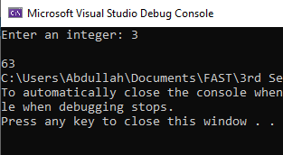

**Question 2**

Include Irvine32.inc

.code

main PROC

MOV ax, -128d

shl eax, 16

sar eax, 16

call writeint

exit

main endp

end main

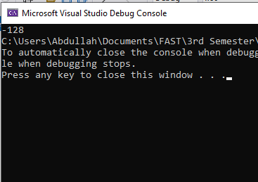

**Question 3**

Include Irvine32.inc

.data

bMinutes BYTE ?

.code

main PROC

MOV bx, 1111001011010110b ;Extract 22 in decimal.

MOV dx, bx

SHR dx, 5 ;dx = 0000011110010110

and dl, 00010110b

MOV bMinutes, dl

MOV eax, 0

MOV al, bMinutes

call writedec

exit

main endp

end main

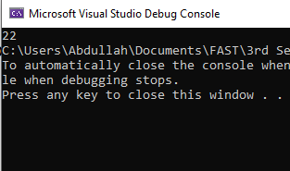

**Question 4**

Include Irvine32.inc

.data

val1 SDWORD 90

val2 SDWORD -30

val3 SDWORD 15

.code

main PROC

MOV eax, 0

MOV ax, 0100101010100111b

SHL ax, 15

MOV bx, ax ; Lowest bit of ax is now in bx

MOV ax, 0100101010100111b

SHRD bx, ax, 1

exit

main endp

end main

**Question 5**

Include Irvine32.inc

.data

val1 SDWORD 90

val2 SDWORD -30

val3 SDWORD 15

.code

main PROC

MOV eax, val2

cdq

IDIV val3

MOV ecx, eax

MOV eax, val1

MOV edx, 0

IDIV val2

IMUL eax, ecx

MOV val1, eax

call writeint

exit

main endp

end main

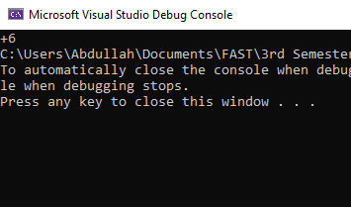

**Question 6**

INCLUDE irvine32.inc

.data

Val1 QWORD 0123456789ABCDEF1h

Val2 QWORD 0123456789ABCDEF2h

ans DWORD 3 DUP(?)

.code

main PROC

mov esi,OFFSET Val1

mov edi,OFFSET Val2

mov ebx,OFFSET ans

mov ecx,2

call Extended_Add

mov eax,DWORD PTR ans + 8

call WriteHex

mov eax,DWORD PTR ans + 4

call WriteHex

mov eax,DWORD PTR ans

call WriteHex

exit

main endp

Extended_Add PROC

pushad

clc

LoopTime:

mov eax,[esi]

adc eax,[edi]

pushfd

mov [ebx],eax

add esi,4

add edi,4

add ebx,4

popfd

loop LoopTime

adc WORD PTR [ebx],0

popad

ret

Extended_Add endp

end main

